|  |  |
| --- | --- |
| King Of tokyo | User manual    Jonathan Ham, Lam Nguyen, Aurelio Torres |

Table of Contents

1.0 General Information 2

1.1 System Overview 2

2.0 System Summary 2

2.1 System Configuration 2

2.2 User Access Levels 2

2.3 Contingencies 2

3.0 Getting Started 2

3.1 Installation 2

3.1.1 Java is required 2

3.1.2 Download King of Tokyo 2

3.2 System Menu 3

3.2.1 To Battle 3

3.2.2 Exit System 3

4.0 Playing the Game 3

4.1 Contents and Game Elements 3

4.1.1 Monster Characters 3

4.1.2 Black Dice 4

4.1.3 Tokyo “Board” 4

4.1.4 Power Cards 5

4.1.5 Energy Cubes 5

4.2 Initialization (Setup) 6

4.3 How To Play 6

Turn Overview: 6

4.3.1. Roll Dice 6

4.3.2. Resolve Dice 7

4.3.3. Enter Tokyo 8

4.3.4. Buy power Cards 8

4.3.5. End of Turn 8

4.4 End of Game 9

5.0 Glossary 9

# General Information

## System Overview

The game “King of Tokyo” is designed to be a multiplayer game with 2-6 players battling against each other to see who can reign supreme over Tokyo City Roll your dice and choose your strategy to stomp your way to victory!

# System Summary

## System Configuration

King of Tokyo is a cross-platform game that can be play on any device that has Java JRE 8 or greater installed.

Internet connection is required to download the game.

## User Access Levels

Everyone can use/play the game.

## Contingencies

If the game is accidentally interrupted while playing, the game resets and battle progress is lost.

If the game itself gets corrupted, redownload the game.

# Getting Started

## Installation

### Java is required

In order to play, Java JRE 8 or greater is required to be installed. To learn about java and how to install it, please visit

<https://www.java.com/en/download/faq/whatis_java.xml>

### Download King of Tokyo

Download from GitHub: <https://github.com/jondwoo/King-of-Tokyo.git>

## System Menu

### To Battle

Choosing ‘To battle’ is the beginning of an epic battle that will decide who becomes the King Of Tokyo.

After choosing to battle, the number of fighters will be selected (2-6). There will be a list of customizable Monsters to select from.

After selecting the monster that gets to smash first, the epic battle begins.

### Exit System

To exit King of Tokyo game, click the ‘Exit Game’.

# Playing the Game

## Contents and Game Elements

### Monster Characters

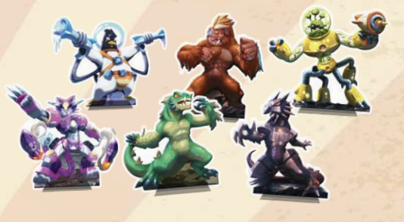

These 6 monsters represent the monsters you play as. Choose one and attack, defend, or power up your monster in order to be the last one standing!

### Black Dice

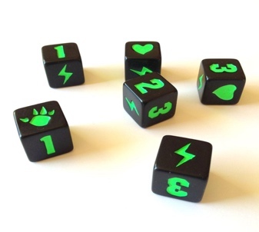

Once rolled, each die has 6 symbols that represent that actions you can take on your turn:

 Gain Victory points

 Gain Energy cubes

 Smash other monsters to lose HP

 Gain HP

### Tokyo “Board”

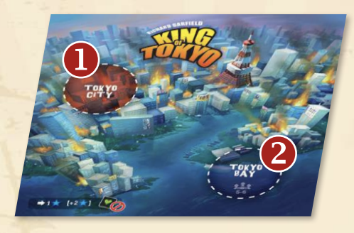

The board represents a physical view of the playing field. Tokyo city within the game will be represented via GUI. The layout will only include “Tokyo City” and not “Tokyo Bay”. Tokyo City is where the last monster must be in order to be King!

### Power Cards

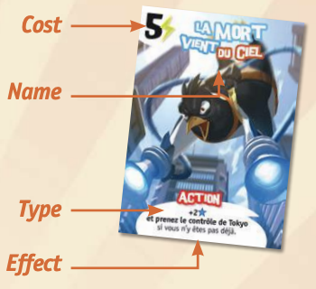

Power cards provide a way for a monster to receive perks or benefits. Buy these from the shop with energy cubes in order to gain the upper hand against many other players! Power cards can be one of two different types:

 Keep these face-up in front of you until the game ends

 Remove these cards immediately after being used

### Energy Cubes

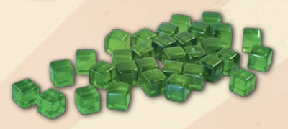

Gain energy cubes equal to the number of  rolled during the roll diced phase. Spend these in the shop to purchase different power cards to activate certain card effects!

## Initialization (Setup)

1. Each player selects a monster to play as. The player may choose to name and customize his/her player in the customization screen. Each monster will begin with 10 HP and 0 VP.
2. Click start game for Tokyo City to load into the GUI
3. The power cards will be shuffled
4. The first three power cards from the deck will be displayed for players to purchase
5. The dice will be available to be rolled
6. Each player will have a dedicated area to hold their energy cubes in

## How To Play

### Turn Overview:

1. Roll Dice
2. Resolve Dice
3. Enter Tokyo
4. Buy Power Cards
5. End of turn

### 4.3.1. Roll Dice



On your turn, you can roll the dice up to three times. You can stop rolling anytime by clicking the ‘Resolve Dice’ button.

On the first Roll, by clicking ‘Roll Dice’ button, you will roll the 6 black dice (and 1 or 2 green dice if you have a Power card that lets you roll them). For your second Roll, if you like some of your results, you can set them aside by clicking the results which you want to keep, and you can roll the ones you don’t like again. For your third Roll, if you change your mind, you can roll any dice you set aside again, along with any you want to change.

After you finish your three Rolls (or you decide to stop), the system will automatically update all the result you get and show it on the information box.

### 4.3.2. Resolve Dice

This is how your points are updated. You don’t have to worry about this because the system will calculate and update all the points for you.

1. **Victory Points:**

If you roll three-of-a-kind of 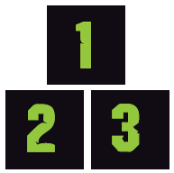 (one of these numbers) gain as many Victory Points (VP) as the number.

Each additional dice rolled with the same face gains you 1 additional VP.

For example: if you roll 2, 2, 2, 2, 3, 1 then you would get +2 points for the set of 3 2’s and then 1 extra point for the fourth 2.

1. **Energy:**

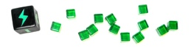

.

You gain 1 energy cube per dice showing the lightning bolt

You can use energy point to buy any power cards in your turn.

You may now buy one or more power cards by clicking the ‘Shop’ button on the screen. Spend as many energy cubes as indicated by one of the 3 face-up power cards. Purchased cards are replaced immediately and can then be purchased on that same turn. Players may repeat this action as 8many times during their turn as they have energy to do it.

1. **Smash:**

You deal 1 damage per clawed hand  (smash) to all other monsters that are not in the same space as you. You lose 1 Health Point  for each. The points will be automatically updated to you and other players.

* If you are in Tokyo and you get , all Monsters outside of Tokyo will lose Health Point (HP)
* If you are outside of Tokyo and you roll , only the Monster who is in Tokyo lose HP  The Monster can then decide to Yield and leave Tokyo or stay.

Each clawed hand represents 1 damage. If a monster Yields Tokyo then it moves out of the Tokyo space, but still takes the 1 damage. The current Monster who causes the damage must enter Tokyo.

1. **Heal** 

If you are outside of Tokyo, you can gain 1 HP  for each  rolled.

If you are in Tokyo, you do not gain any HP when you roll  except you have a power card.

Note: Your HP cannot exceed 10.

### 4.3.3. Enter Tokyo

When the game just starts, all the players will have to roll the dice. Whoever has the most  results will be placed in the Tokyo.

If no one is in Tokyo, your Monster will be placed inside Tokyo city.

You only can Yield when you lose HP  from  rolled by a Monster.

Being in Tokyo (Tokyo City or Tokyo Bay) has some advantages and

disadvantages:

* You gain 1 VP when you enter Tokyo.
* You gain 2 VP if you start your turn in Tokyo.
* Other Monsters will attack you.
* You can have the option by click the ‘Yield’ button to leave Tokyo after losing HP from  rolled by the other Monster.

### 4.3.4. Buy power Cards

You may buy one or more of the three available cards. To buy a card, you need to spend as many  as the cost indicated next to the cards. If you have enough Energy Points, you can click the ‘Shop’ button to buy a card.

Players may also spend 2 energy to sweep the 3 existing cards into the discard and draw 3 new ones which are then immediately available for purchase. Players may repeat this action as many times during their turn as they have energy to do it.

You can use the card you purchased in the next turn.

### 4.3.5. End of Turn

Certain Power card effects activate at the end of your turn.

Once you’re done, the ‘Roll Dice’ will be available for the next player.

## End of Game

You must end your turn, alive, with 20 Victory Points VP or be the last monster remaining in the game. If you have 20 VP but end up with 0 health by the end of your turn then you still lose the game.

# Glossary

* **Roll**: the act of click the ‘Roll Dice’ button. Before a Roll, a player can keep aside one or more dice of the dice previously rolled by click results. He can also decide to roll one or more of the previously set aside dice again.
* **Yield**: A Monster may Yield Tokyo only after losing HP from  rolled by another Monster. The smashing Monster must then take his place during the Enter Tokyo step.
* **Smash**: when you roll  to make Monsters lose HP 